Samuel Oren Neptune
September 27, 1867 – August 13, 1870

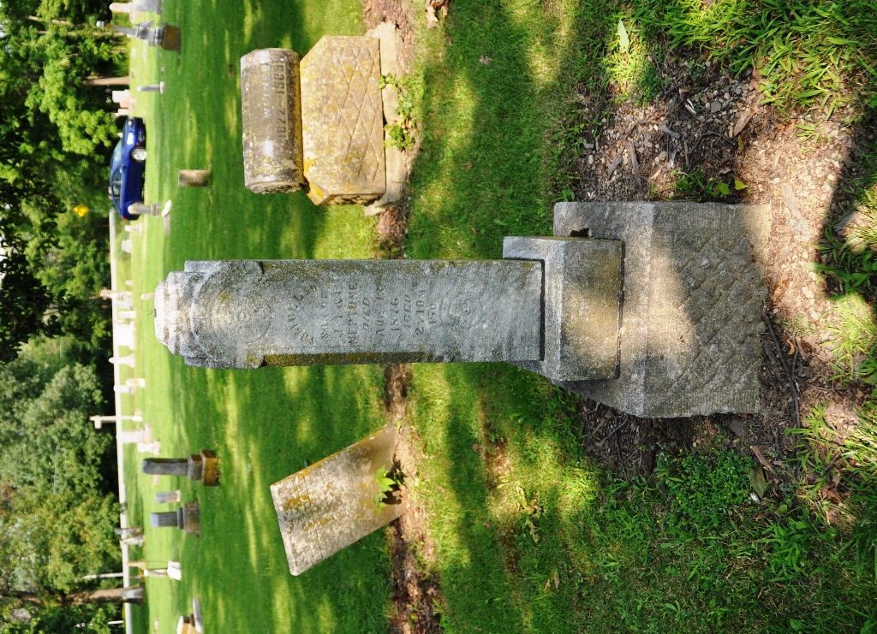
Photo by Deb Curry

Samuel Oren Neptune from tree Counterman Family Tree
Birth 27 Sep 1867
Death 13 Aug 1870
Father James Ira Neptune (1828-1904)
Mother Isabelle Flagg (1835-1919

