Ira Curtis Neptune
February 13, 1862 – March 22, 1863

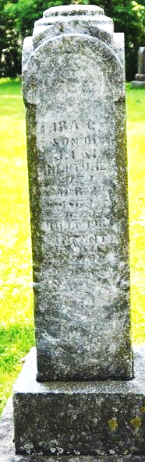
Photo by Deb Curry

Ira Curtis Neptune from tree NeptuneDescendancy
Birth 13 Feb 1862 Indiana, USA
Death 22 Mar 1863 Indiana, USA
Father James Ira Neptune (1826-1905)
Mother Isabelle Flagg (1835-1919)

