Horatio Murray
January 6, 1801 – March 10, 1869

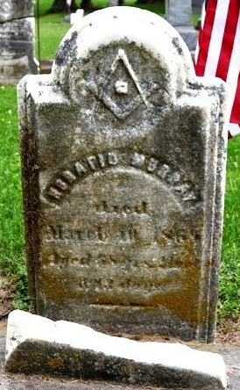
Photo by Deb Curry

Horatio Murray from tree Eady Family Tree
Birth 6 Jan 1801 Williston, Chittenden, Vermont, USA
Marriage 31 Jul 1856 Pleasant Mills, Adams, Indiana, USA
Residence 1863 Indiana, USA
Death 10 Mar 1869 Pleasant Mills, Adams, Indiana, USA
Father Curtis Murray (1767-1831)
Mother Anna Farlin (1773-1803)
Spouse Diana Darwin (1803-1854)
Spouse Martha Matthewson Fuller (1822-1894)

