Calvin S. Murray
January 17, 1831 – November 30, 1892

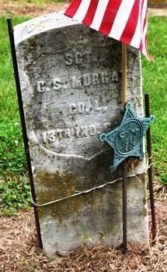
Photo by Deb Curry

Calvin Murray
in the U.S., Civil War Soldiers, 1861-1865
Name Calvin Murray
Side Union
Regiment State/Origin Indiana
Regiment 13th Regiment, Indiana Cavalry
Company L, G
Rank In Private
Rank Out Sergeant
Alternate Name Calvin/Murry
Film Number M540 roll 54

**
Indiana, U.S., Civil War Soldier Database Index, 1861-1865
Name Calvin Murray
Birth Year abt 1832
Age 32
Enrollment Date 22 Feb 1864
Discharge Date 18 Nov 1865
Place Indianapolis, Indiana
Company G
Cavalry, Battery, Unit 13th Cavalry
Regiment 131
Notes Transferred from Co. L. June 9, 1864. Corpl. June 10, 1864; Sgt. October 31, 1865.

**
Calvin MURRAY from tree Waterhouse Family Tree 2013(1)(1)_AutoBackup
Birth 17 Jan 1831 Williston, Chittenden, Vermont, USA
Marriage 8 Jan 1860 Decatur, Adams, Indiana, USA
Residence 1880 Decatur, Adams, Indiana, USA
Death 30 Nov 1892 Decatur, Adams, Indiana, USA
Father Horatio MURRAY (1798-1869)
Mother Diana DARWIN (1803-1854)
Spouse Mary Elizabeth SEWELL (1840-1875)

