Letie Miller

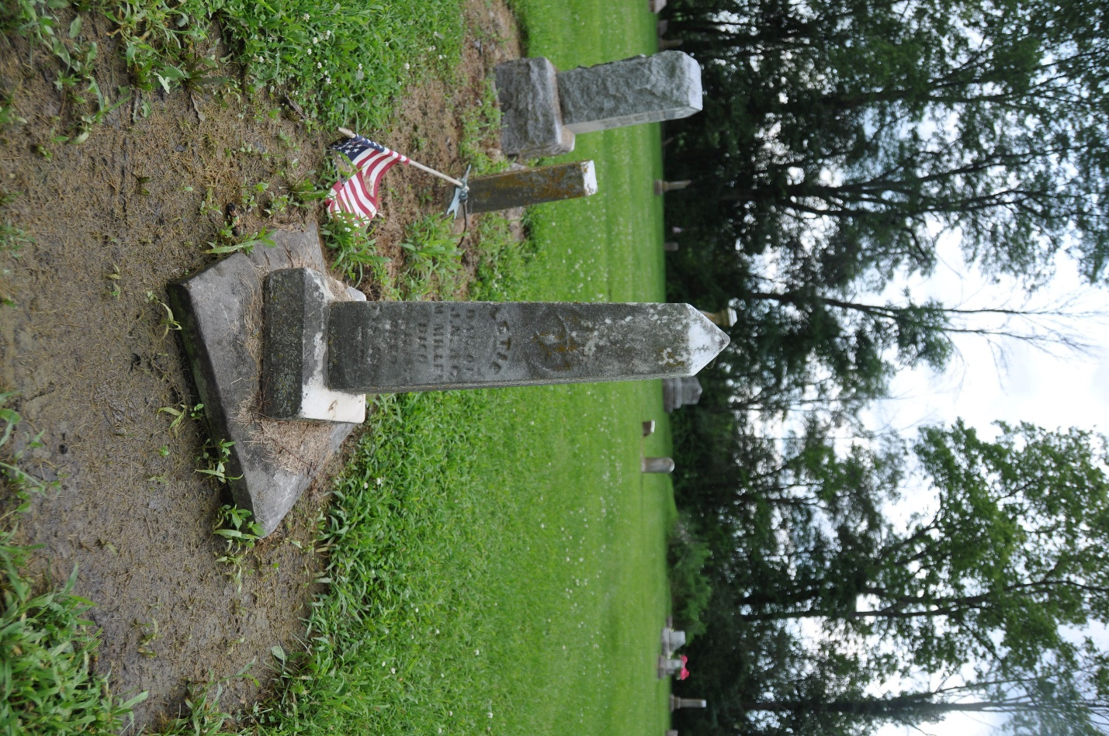
Photo by Deb Curry

No further information found at this time

