James B. Miller
August 17, 1825 – March 25, 1876

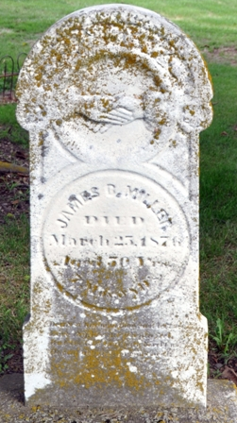
Photo by Deb Curry

No further information found at this time

