Sylvenus Benidict Merriss
June 30, 1825 – June 5, 1898

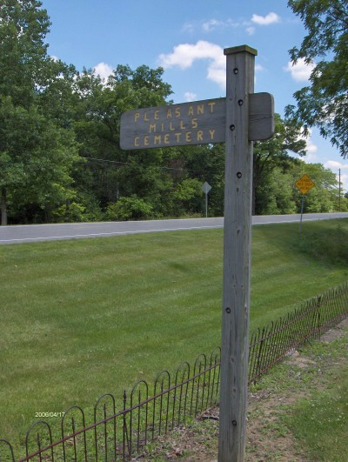
Photo by Margie Pearce
Obit from Karin King

S. B. Merriss, of Pleasant Mills, who has been suffering for several weeks from cancer of the stomach, was reported last evening as being in a dying condition. He has not eaten anything for several days and has been kept alive only by the use of stimulants and morphine. Mr. Merriss is one of the pioneers of this county and has many friends here. He is the father of Mrs. H. A. Fristoe. His friends will grieve to hear of the critical condition he is in, and it is to be hoped that he may yet rally, although Dr. Christy, of Wilshire, who is attending him, has given no encouragement that he can live.

Decatur Democrat, Adams County, Indiana
Thursday, June 2, 1898

