Edward J. McLeod
December 18, 1849 – February 6, 1864

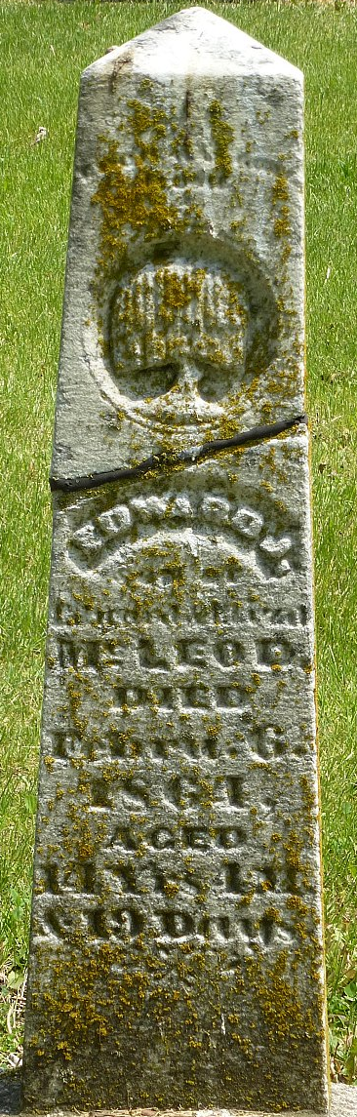
Photo by Deb Curry

Edward J McLeod from tree McLeod Family Tree
Birth 18 Dec 1849 Indiana, USA
Residence 1860 Adams, Indiana, USA
Death 6 Feb 1864
Father Edward McLeod (1814-1880)
Mother Eliza rose (1814-1885)

