Ezra McCullough
May 14, 1860 – May 14, 1860

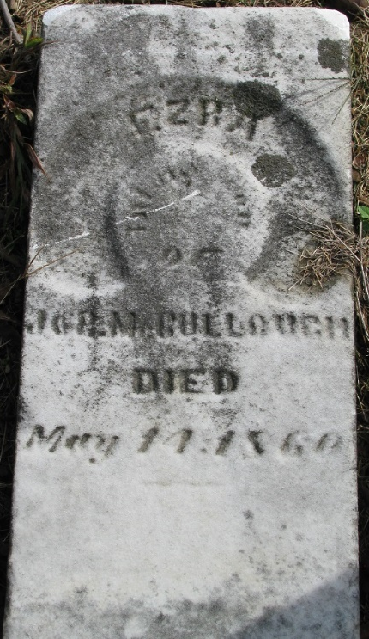
Photo by PLS

Ezra McCullough from tree John Myers family tree(1)
Birth 14 May 1860 Adams, Indiana, USA
Death 14 May 1860 Adams, Indiana, USA
Father James Rankin McCullough (1815-1881)
Mother Rhoda Shaffer (1818-1908)

