Albion Mauller
November 7, 1900 – March 9, 1917

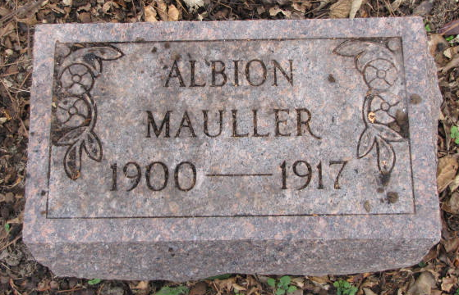
Photos by Barbara Baker Anderson

ILL SHORT TIME
Albion Mauller, Popular Pleasant Mills Youth, Died This Morning
BRAIN INFLAMMATION
Sick But Two Days and a Half - Funeral Will be Held Sunday Morning
The death of Albion Mauller, well known and beloved son of Mr. and Mrs. Albert Mauller, of Pleasant Mills, died this morning after an illness of less than three days with brain fever, shocked the many friends of the family in his own community, here and elsewhere over the county.
The boy was but 16 years old, a student in the Pleasant Mills school and very popular. He became ill Tuesday and grew rapidly worse, death relieving his suffering early this morning.
The funeral services will be held at the Methodist Church Sunday morning at 10 o'clock.
Besides the parents, Albion is survived by one brother and three sisters.

Decatur Daily Democrat, Adams County, Indiana
Friday, March 9, 1917
**

Indiana, Death Certificates, 1899-2011

Name: Albion M Mauller
Gender: Male
Race: White
Age: 16y, 4m 2d
Marital status: Single
Birth Date: 9 Mar 1917 (sic - should be 7 Nov 1900)
Birth Place: Adams Co Ind.
Death Date: 9 Mar 1917
Death Place: Pls Mills, Adams, Indiana, USA
Father: Albert M Mauller, informant
Mother: Ada Brown
Burial: March 11, 1917 - Pls Mills Cemetery

**
Albion M Mauller from tree Hanrahan Family Tree
Birth 1900 Pleasant Mills, Adams, Indiana, USA
Residence 1910 Adams, Indiana, USA
Death 9 Mar 1917 Pleasant Mills, Adams, Indiana, USA
Father Albert M Mauller (1873-1967)
Mother Adah Martha Brown (1878-1952)

