Joshua Mathewson
June 17, 1854 – December 1, 1909

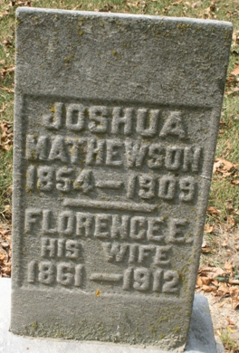
Photo by Jacquie Eisenhut

A DEATH MESSAGE
Joshua Matthewson, of Lima, Ohio, Stricken With Paralysis
DIED VERY SUDDENLY
Was a Former Resident and Lived Here Many Years
A message from Lima, Ohio, brought the unwelcome news of the death of Joshua Matthewson, a former resident of this city and well known here. H. W. Matthewson left for that place at once and will remain until after the funeral services. The news of his illness and death was meager, the only thing known is that he was stricken with paralysis and died suddenly, his relatives here not knowing of any illness until the death message came.
He was born and raised in this county and for many years was a resident of this city. His mother is still living on the old home farm near Pleasant Mills, living with her daughter, Mrs. L. A. Springer. Another sister, Mrs. S. O. Bowser, lives near Monroe and two brothers, H. W. and N. B. Matthewson, are residents of Pleasant Mills.
The deceased was about fifty-five years old and for the past several years has lived in Lima, Ohio, where he is well known and a highly respected citizen.

Decatur Daily Democrat; Adams County, Indiana
December 1, 1909
**
Indiana, Marriages, 1810-2001

Name: Joshua Mathewson
Gender: Male
Event Type: Marriage Registration (Marriage)
Marriage Date: 20 Aug 1879
Marriage Place: Indiana, United States
Spouse: Florence E Burkhead
Page: 266
FHL Film Number: 002321470

**
Ohio, Deaths, 1908-1953
Name Joshua Mathewson
Sex Male
Age 55
Birth Date 17 Jun 1854; Birthplace Adams Co., Ind.
Burial Date 03 Dec 1909; Burial Place Pleasant Mills, Ind.
Marital Status Married
Race W
Father's Name Alferd Mathewson
Father's Sex Male; Father's Birthplace N.Y.
Mother's Name Elizabeth Johnson
Mother's Sex Female
Event Type Death
Event Date 01 Dec 1909
Event Place Lima, Allen, Ohio
Event Place (Original) Lima, Allen, Ohio
Informant C. H. Mathewson
Source Details fn 59360

