Joshua Mathewson
December 24, 1797 – January 21, 1865

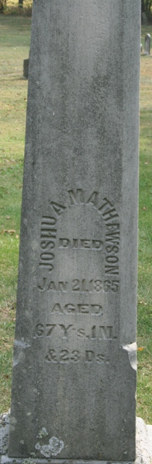
Photo by Jacquie Eisenhut

Joshua Mathewson from tree Branch Family Tree
Birth 24 Dec 1797 Massachusetts, USA
Marriage 1823 Elmira, Chemung, New York, USA
Residence 1860 Pleasant Mills, Adams, Indiana, USA
Death 21 Jan 1865 Adams, Indiana, USA
Father Joshua Mathewson (1771-1823)
Mother Margaret Hale (1772-1821)
Spouse Almyra Flagg (1803-1879)

