Harvey F. Mathewson
April 18, 1833 – March 31, 1853

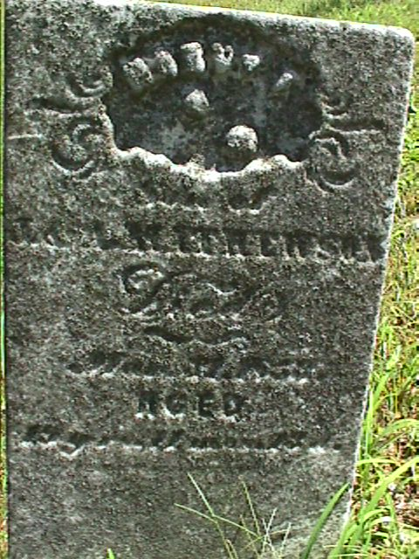
Photo by Jacquie Eisenhut

Harvey F Mathewson from tree Lockwood/Minnemeyer Family Tree
Birth 1833 New York, USA
Residence 1850 Adams, Indiana, USA
Death 31 Mar 1853
Father Joshua Mathewson (1797-1865)
Mother Almira Flagg (1803-1879)

