Florence Emaline (Burkhead) Mathewson
September 24, 1861 – May 10, 1912

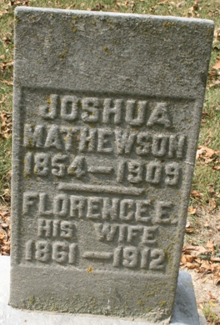
Photo by Jacquie Eisenhut

DIED AT LIMA, O.
Funeral of Mrs. Eva Mathewson, Former Adams Lady, Tuesday
AT PLEASANT MILLS - Death Occurred Friday from Heart Trouble Has Many Relatives Here
The funeral of Mrs. Eva Mathewson, widow of Joshua Mathewson, late of Lima, Ohio, will be held Tuesday afternoon at 1 o'clock at the M. E. Church at Pleasant Mills and will be largely attended by many Adams County relatives and friends of this lady. Her death occurred at Lima, Ohio, Friday, May 10th, from heart disease.
Mrs. Mathewson's maiden name was Eva Burkhead, she being a daughter of Green B. Burkhead, a soldier in Company H, 89th Indiana Volunteers, whose death occurred at Memphis, Tenn., in 1863. Her mother was Mary Murray, daughter of Horatio Murray, one of the pioneers of Adams County, and both the deceased and her late husband were born and reared in this county and lived here until about fifteen years ago, when they moved to Lima, Ohio.
Mrs. Mathewson was the stepdaughter of James R. Boyd of Pleasant Mills and a niece of Ed and Walt Murray of this city. She leaves a family of six grown children - three sons and three daughters.

Decatur Daily Democrat; Adams County, Indiana
Monday, May 13, 1912
**
Ohio, Deaths, 1908-1953
Name Florence Emaline Mathewson
Sex Female
Age 50
Birth Date 24 Sep 1863 [sic]
Birthplace Indiana
Address 737 N. Main
Burial Date 13 May 1912
Burial Place Pleasant Mills, Ind.
Marital Status Widowed
Race white
Father's Name Green Burkhead
Father's Sex Male
Father's Birthplace Indiana
Mother's Name Mary
Mother's Sex Female
Mother's Birthplace Indiana
Event Type Death
Event Date 10 May 1912
Event Place Lima, Allen Co., Ohio
Event Place (Original) Lima, Allen Co., Ohio
Source Details fn 25311
Microfilm Number 1953418
Informant Calvin Mathewson
Indexing Batch B03875-0

