Almira (Flagg) Mathewson
July 11, 1803 – February 2, 1879

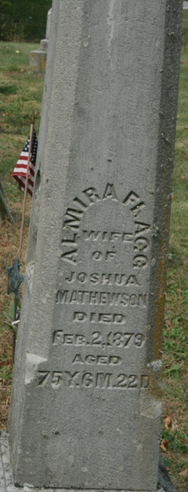
Photo by Jacquie Eisenhut

Almyra Flagg from tree Joseph-Kosch Family Tree
Birth 11 Jul 1803 Vermont, USA
Marriage 1823 Elmira, Chemung, New York, USA
Residence 1870 Adams, Indiana, USA
Death 2 Feb 1879 Allen, Indiana, USA
Father Solomon Flagg (1770-1852)
Mother Eunice Corse (Flagg) (1777-1859)
Spouse Joshua Mathewson (1797-1865)

