Alfred M. Mathewson
July 21, 1828 – April 25, 1891

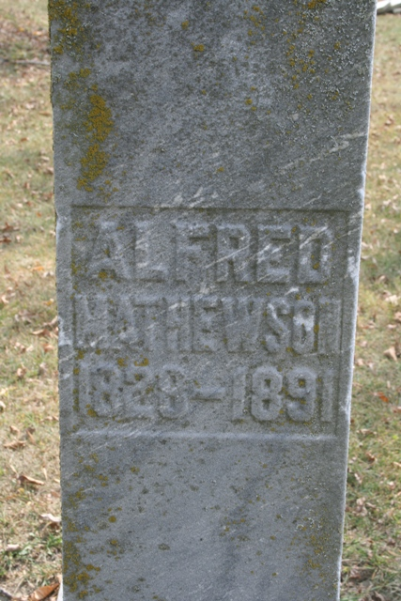
Photo by Jacquie Eisenhut

Alfred Mathewson, one of Adams County's most respected citizens, died last Saturday evening of Bright's disease. His funeral was held at Pleasant Mills last Monday afternoon.
Decatur Democrat; Adams County, Indiana
Friday, May 1, 1891
**
Pleasant Mills Items
Died on the 25th, Alfred Matthewson, aged 62 years, 8 months and 4 days. Funeral last Monday afternoon conducted by Rev. Smith, of Decatur. Mr. Matthewson was one of Adams County's pioneers, and one of our best citizens, and lived a devoted Christian.
Decatur Democrat; Adams County, Indiana
Friday, May 1, 1891
**
Will of Alfred Mathewson
Name in Record Reason for Being in Record Date of Record
Alfred Mathewson; Of St. Mary's Township; makes his last will & testament; Oct. 22, 1890
Elizabeth Mathewson; Wife; receives real estate & personal property during her lifetime
Joshua Mathewson; Son; to share estate with siblings after death of mother
Hester A. Springer; Dau; to share estate with siblings after death of mother
William Mathewson; Son; to share estate with siblings after death of mother
Horatio M. Mathewson; Son; to share estate with siblings after death of mother
Nebraska Mathewson; Dau; to share estate with siblings after death of mother
Kansas B. Mathewson; Dau; to share estate with siblings after death of mother
Hampson Mathewson; Son; to share estate with siblings after death of mother
Jacob Rawley Witnessed Alfred Mathewson making his last will
Adam Hower Witnessed Alfred Mathewson making his last will
Alfred Mathewson Died April 25, 1891
Adam Hower; Subscribing witness; oath of death & validity of will; May 2, 1891
John D. Hale; Clerk; will has been admitted to probate; May 2, 1891
**
Alfred M Matthewson from tree Howie Family Tree
Birth 21 Jul 1828 New York, USA
Marriage 24 Apr 1853 Allen, Indiana, USA
Residence 1880 Adams, Indiana, USA
Death 25 Apr 1891 Allen, Indiana, USA
Father Joshua Matthewson (1797-1865)
Mother Almyra Flagg (1803-1879)
Spouse Elizabeth Johnson (1830-1914)

