Amy Elizabeth McCullough
September 28, 1861 – September 9, 1863

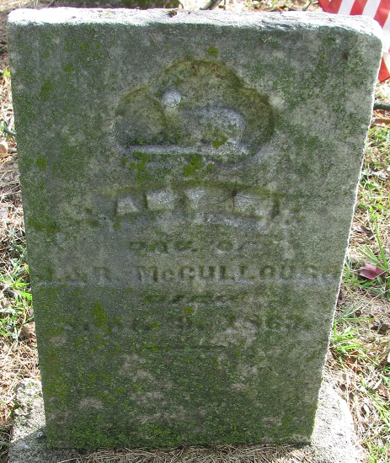
Photo by PLS

Amy Eliabeth McCullough from tree John Myers family tree(1)
Birth 28 Sep 1861 Adams, Indiana, USA
Death 9 Sep 1863 Adams, Indiana, USA
Father James Rankin McCullough (1815-1881)
Mother Rhoda Shaffer (1818-1908)

