Lucinda B. (Hughes) Kessler
May 6, 1861 – August 11, 1949

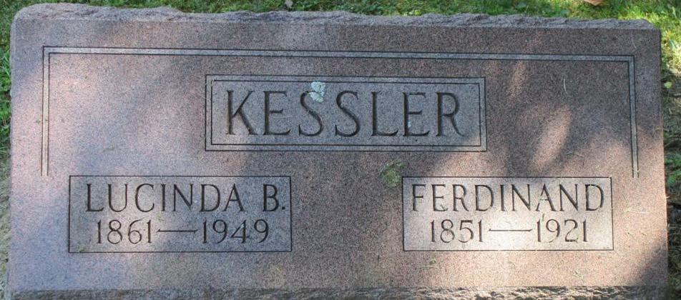
Photo by Nancy Replogle

MRS. BELL KESSLER, 88, DIES THURSDAY
88-Year-Old Monroe Woman is Dead After Short Illness
Mrs. Bell Kessler, 88, a resident of Monroe for many years, died at 11:00 a.m. Thursday at a convalescent home in Fort Wayne where she was admitted three weeks ago. She had been seriously ill for a few weeks.
Mrs. Kessler spent most of her life around Monroe. She was born May 6, 1861, the daughter of Dr. and Mrs. Alex Hughes in Darke County, Ohio.
Surviving is a daughter, Mrs. Mattie Ronkman, Fort Wayne; a son, Robert Hathaway, Springfield, Ohio; two stepsons, James Kessler, Monroe and Frank Kessler, California.
The funeral will be held at 1:30 p.m. at Black's Funeral Home in Decatur and at 2:00 o'clock at the Monroe Methodist church, Rev. W. L. Hall officiating. Burial will be in the Pleasant Mills Cemetery. Friends may call at the funeral home after 7:00 p.m. today.
The Berne Witness; Adams County, Indiana
Friday, August 12, 1949
**

Indiana, U.S., Death Certificates, 1899-2017
Name Belle Kessler
[Belle Hughes]
Gender Female
Race White
Marital Status Widowed
Age 88
Birth Date 6 May 1861
Birth Place Darke County, Ohio
Death Date 11 Aug 1949
Death Place Fort Wayne, Allen, Indiana, USA
Death Registration Date 1949
Father A Hughes
Mother Unknown
Informant Robert Hathaway; Springfield, Ohio
Burial August 14, 1949; Pleasant Mills Cemetery; Pleasant Mills, Indiana
**

Lucinda B Kessler from tree Ann Wehrlie Family Tree

Birth May 1861 Ohio, USA
Marriage 1882
Residence 1930 Adams, Indiana, USA
Death 1949 Indiana, USA
Father Alexander Hughes (1834-1897)
Mother Catharine Hughes (Born 1837)
Spouse Michael William Hathaway (1855-1937)
Spouse Ferdinand Kessler (1847-1921)

