Ferdinand N. Kessler
May 22, 1847 – July 4, 1921

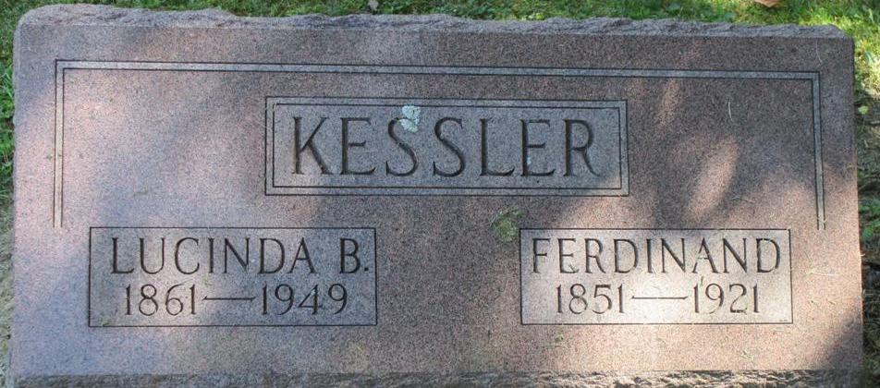
Photo by Nancy Replogle

DEATH IS VICTOR
Ferdinand N. Kessler, Well Known Farmer of Washington Township Died - MONDAY AFTERNOON
From Carcinoma of Liver - Funeral Services To Be Held Wednesday
Ferdinand N. Kessler, well known farmer of Washington township, died at his home yesterday afternoon at 1:30 o'clock, death being due to carcinoma of the liver from which he has been suffering from for some time.
Mr. Kessler was born in Germany, May 22, 1874 [sic], his age at the time of death being seventy-four years. He was the son of Christopher and Catherine Kessler and came to this country a number of years ago locating on a farm in Washington township.
Mr. Kessler was twice married and is survived by five children, four boys and one girl from the first marriage. He was later again married and is survived by the widow, Lucinda B. Kessler and son, Harry, and step-children, Robert and Mattie Hathaway, twenty-two grandchildren and two great-grandchildren.
Funeral services will be held Wednesday afternoon, the cortege to leave the home at one o'clock, in charge of Rev. Zekiel, of the Monroe Methodist church, and Rev. Reckenbaugh, of the Friends church, of Monroe, with burial in the Pleasant Mills Cemetery.

Decatur Daily Democrat, Adams County, Indiana
Tuesday, July 5, 1921
**
Indiana, Death Certificates, 1899-2011
Name: Ferdinand N. Kessler
Gender: Male
Race: White
Age: 74y, 1m, 12d
Marital status: Married
Birth Date: 22 May 1847
Birth Place: Germany
Death Date: 4 Jul 1921
Death Place: Washington, Adams, Indiana, USA
Father: Christopher Kessler
Mother: Catharine Kable
Informant: Henry L Kessler
Burial: July 6, 1921-Pleasant Mills Cemetery

