Catherine (Wagoner) Hughes
November 29, 1839 – September 19, 1903

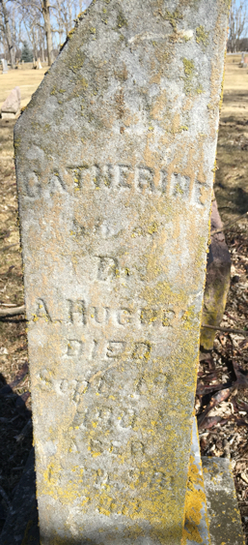
Photo by Barbara Baker Anderson

Indiana, Death Certificates, 1899-2011

Name: Catharine Hughes
Gender: Female
Race: White
Age: 65
Marital status: Widowed
Birth Date: 29 Nov 1837
Birth Place: Ohio
Death Date: 19 Sep 1903
Death Place: Monroe, Adams, Indiana, USA
Father: William H ?Wafener?
Mother: Elizabeth Hutchins
Spouse: Alexander Hughes
Informant: Lucinda Bell Kesler, Monroe, Ind.
Burial: Sept 20, 1903 - Pleasant Mills

