Dr. Alexander Hughes
November 4, 1833 – October 20, 1897

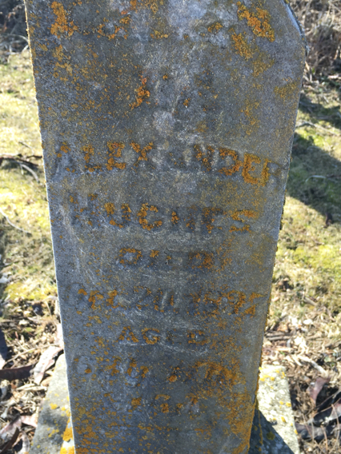
Photo by Barbara Baker Anderson

Dr. Alexander Hughes from tree Wetzel Family Tree
Birth 4 Nov 1833 Darke, Ohio, USA
Marriage 1850
Residence 1880 Monroe City, Adams, Indiana, USA
Death 20 Oct 1897 Allen, Indiana, USA
Father Humphrey Hughes (1806-1891)
Mother Susannah Priest (1809-1887)
Spouse Catharine Wagoner (1823-1903)

