Thomas A. Harper
May 11, 1866 – August 2, 1866

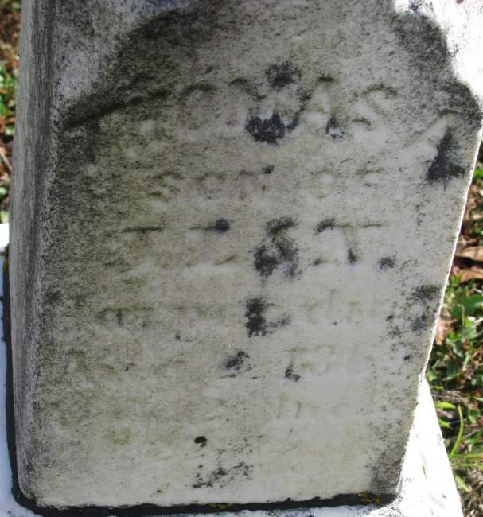
Photo by PLS

No further information found at this time

