Nancy (Savage) Harper
March 18, 1827 – May 22, 1898

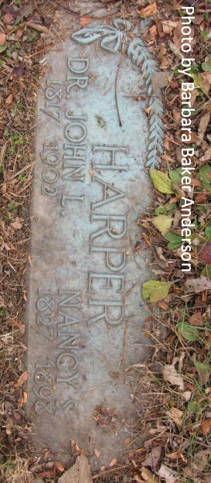
Photo by Barbara Baker Anderson

Mrs. J. L. Harper died at her home in Pleasant Mills, Sunday evening, May 22. Funeral occurred from the residence Tuesday. After short services conducted by Rev. D. Schenck, her remains were laid to rest in the Pleasant Mills Cemetery.

Decatur Democrat, Adams County, Indiana
Thursday, May 26, 1898

**
Nancy J Savage from tree McRae Family Tree
Birth 18 Mar 1827 Ohio, USA
Marriage 31 Oct 1855 Illinois, USA
Residence 1880 Adams, Indiana, USA
Death 22 May 1898
Father Thomas Savage (Born 1787)
Mother Ann McComb (Born 1789)
Spouse John Little Harper (1817-1902)

