Dr. John Little Harper
April 8, 1817 – March 23, 1902

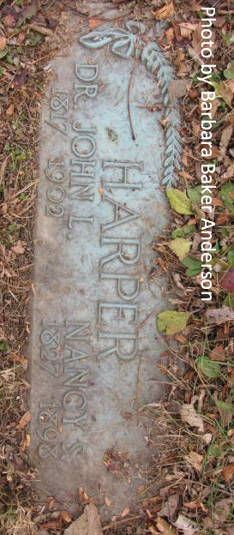
Photo by Barbara Baker Anderson
John Little Harper
in the Indiana, U.S., Death Certificates, 1899-2017
Name John Little Harper
Gender Male
Race White
Marital Status Widowed
Age 84
Birth Date 8 Apr 1817
Birth Place Fayette County, Pennsylvania
Death Date 23 Mar 1902
Death Place Pleasant Mills, Adams, Indiana, USA
Death Registration Date 1902
Father John Harper
Mother Little
Spouse Nancy (deceased)
Informant Mrs. Louis Warner; Pleasant Mills, Indiana
Burial March 25, 1902; Pleasant Mills

**
John Little Harper from tree McRae Family Tree
Birth 8 Apr 1817 Fayette, Pennsylvania, USA
Marriage 31 Oct 1855 Marion, Williamson, Illinois, USA
Residence 1900 Adams, Indiana, USA
Death 23 Mar 1902 Pleasant Mills, Adams, Indiana, USA
Father John Johnson Harper (1771-1853)
Mother Fanny Little (1775-1833)
Spouse Maria Louisa "Eliza" Stoops (1823-1901)

