Infant son Harper
February 20, 1866 – February 20, 1866

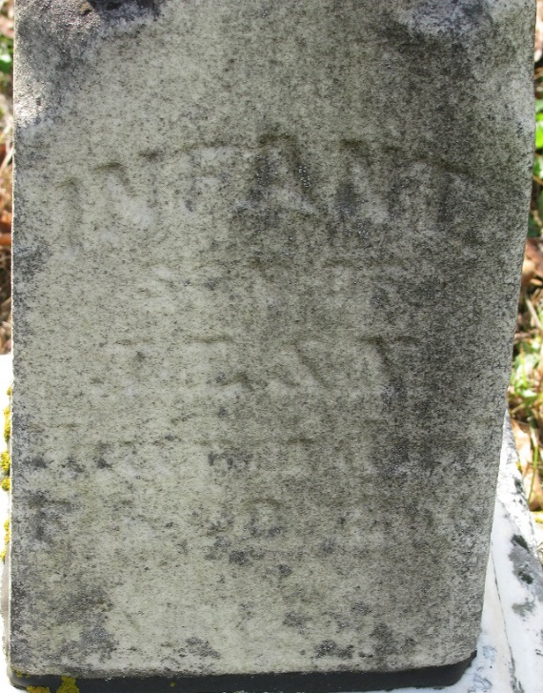
Photo by PLS

No further information found at this time

