Clarisa A. Harper
January 18, 1857 – October 23, 1858

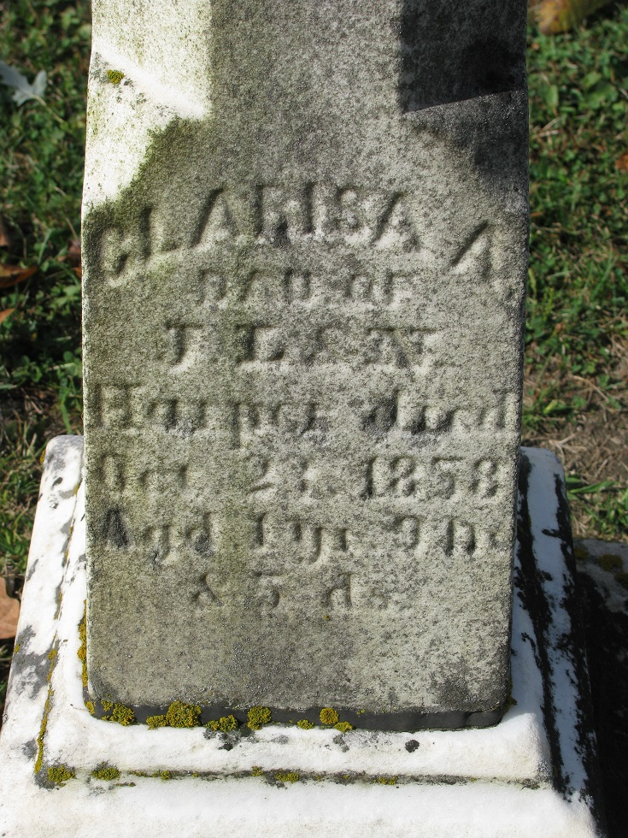
Photo by PLS

Clarisa A Harper from tree Spencer Family Tree
Birth 18 Jan 1857
Death 23 Oct 1858
Father John Little Harper (1817-1902)
Mother Nancy Savage (1826-1898)

