Wilma Hakes
July 8, 1900 – September 25, 1901

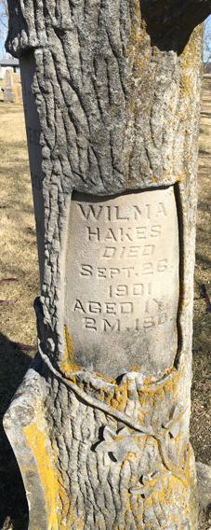
Photo by Barbara Baker Anderson

Pleasant Mills News –

The funeral of little Wilma, the fourteen-month-old daughter of William Hakes, was held at the M. E. Church Thursday morning. The services were conducted by Rev. E. Kohn and were very impressive. Its remains were laid to rest in the cemetery at this place, by the side of its mother who preceded it a few weeks ago.

Decatur Democrat; Adams County, Indiana
A weekly newspaper
Thursday, October 3, 1901

**
Indiana, U.S., Death Certificates, 1899-2017
Name Wilma Hakes
Gender Female
Race White
Marital Status Single
Age 1 year, 2 months, 15 days?
Birth Date abt 1900
Birth Place Adams
Death Date 25 Sep 1901
Death Place Saint Marys, Adams, Indiana, USA
Death Registration Date 1901
Father Joseph Hakes
Mother Susan I ??
Informant J. W. Hakes
Burial September 26, 1901; Pleasant Mills

