George F. Gephart
November 26, 1886 – December 21, 1906

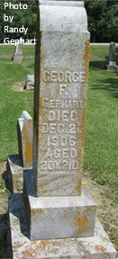

George F. Gephart, son of Phillip and Cary Gephart, was born near Rivarre, St. Marys township, Adams county, November 26, 1886, died at Pleasant Mills, December 21, 1906. About three years ago while in Michigan he was stricken with measles, from which he never completely recovered. This malady gradually developed into tuberculosis which finally caused his death.
About three years ago he united with the St. Paul church of this vicinity. Just previous to his death he gave strong evidence that he was saved and was going home. Three brothers and one sister preceded him to the grave. His father, mother, two brothers and one sister survive. The funeral was held at the M. E. church at Pleasant Mills, a very large number being present. Rev. C. B. Sweeney was officiating minister. Interment took place in the Pleasant Mills cemetery.

Decatur Daily Democrat, Adams County, Indiana
Thursday, 3 January 1907

