Susannah (Maynard) Fuller
May 3, 1779 – October 15, 1843

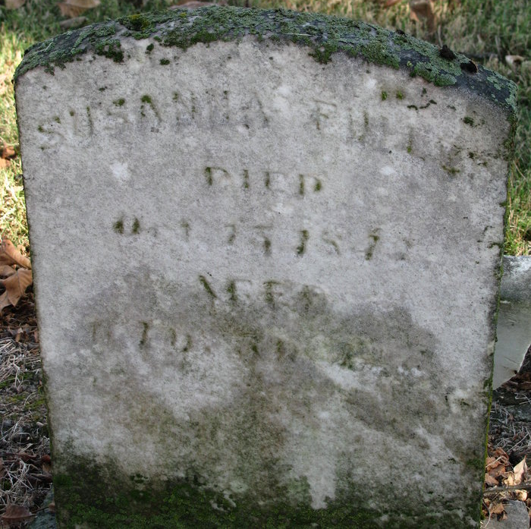
Photo by PLS

Susannah Maynard from tree Wolff Family Tree 2009
Birth 3 May 1779 Bolton, Worcester, Massachusetts, USA
Marriage 13 Oct 1803 Berlin, Worcester, Massachusetts, USA
Residence 1840 Adams, Indiana, USA
Death 15 Oct 1843 Pleasant Mills, Adams, Indiana, USA
Father Abner Maynard (Born 1752)
Mother Susannah Greene (Born 1756)
Spouse Edward S Fuller (1767-1837)

