Solomon H. Fuller
March 24, 1769 – November 27, 1852

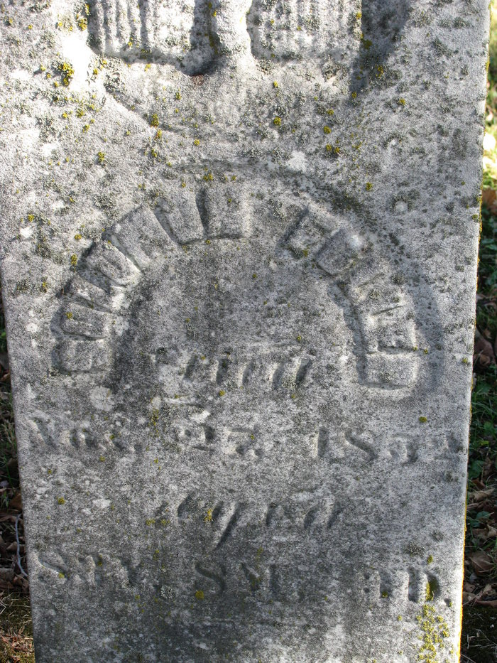
Photo by PLS

Solomon H Fuller from tree Patterson/Larson Family Tree
Birth 24 Mar 1769 Lynn, Essex, Massachusetts, USA
Residence 1850 Adams, Indiana, USA
Marriage 1851 Lawrence, Essex, Massachusetts, USA
Death 27 Nov 1852 Pleasant Mills, Adams, Indiana, USA
Father Edward Fuller (1722-1802)
Mother Ruth Shepard (1725-1834)

