Martha (Mathewson) Fuller-Murray
August 1, 1824 – March 5, 1894

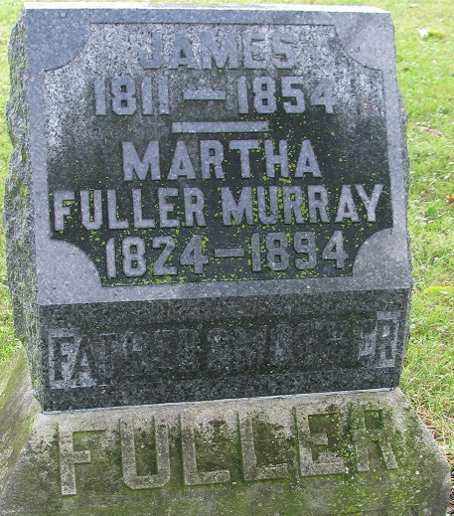
Photo by PLS

Will of Martha Murray

Name in Record Reason for Being in Record Date of Record
Martha Murray; Makes her last will & testament; May 1, 1893
Abner M. Fuller; Son; shares personal property and real estate with siblings
Phoebe Murray; Daughter; shares personal property and real estate with siblings
Walter R. Murray; Son; shares personal property and real estate with siblings
Edgar W. Murray; Son; shares personal property and real estate with siblings
James Murray & wife; Previously sold a portion of real estate not inherited by 'children'
Henry & Jesse Smith; Purchased land by James Murray & wife
Andrew Teeple; Now owns land sold by James Murray & wife
Abner M. Fuller; Son; appointed executor of will of Martha Murray
W. H. H. France Witnessed Martha Murray making her last will
John T. France Witnessed Martha Murray making her last will
Martha Murray Died March 5, 1894
John T. France; Subscribing witness; oath of death & validity of will; March 14, 1894
John H. Lenhart; Clerk; will has been admitted to probate; March 14, 1894

**
Martha Mathewson from tree Eady Family Tree

Birth 1 Aug 1822 New York, USA
Marriage 31 Jul 1856 Pleasant Mills, Adams, Indiana, USA
Residence 1880 Adams, Indiana, USA
Death 5 Mar 1894 Pleasant Mills, Adams, Indiana, USA
Father Joshua Mathewson (1797-1865)
Mother Almyra Flagg (1804-1879)
Spouse James Fuller (1811-1854)

