James Fuller
May 28, 1811 - 1854

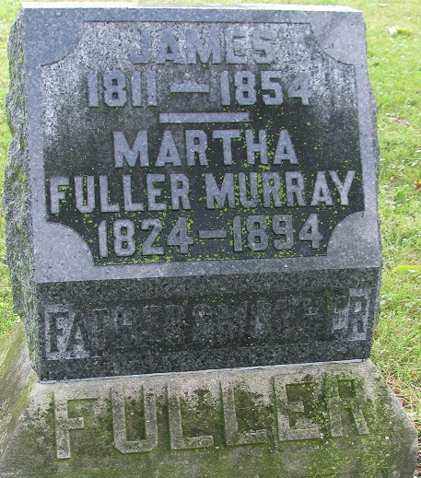
Photo by PLS

James Fuller from tree The Ancestors and Family of Lisa Goodman Lawrence
Birth 28 May 1811 Lancaster, Worcester, Massachusetts, USA
Marriage 20 Aug 1840 Allen, Indiana, USA
Death 1854 Adams, Indiana, USA
Father Edward Fuller (1767-1837)
Mother Susannah Maynard (1779-1843)
Spouse Martha Mathewson (1822-1894)

