Edward S. Fuller
March 23, 1767 – August 27, 1837

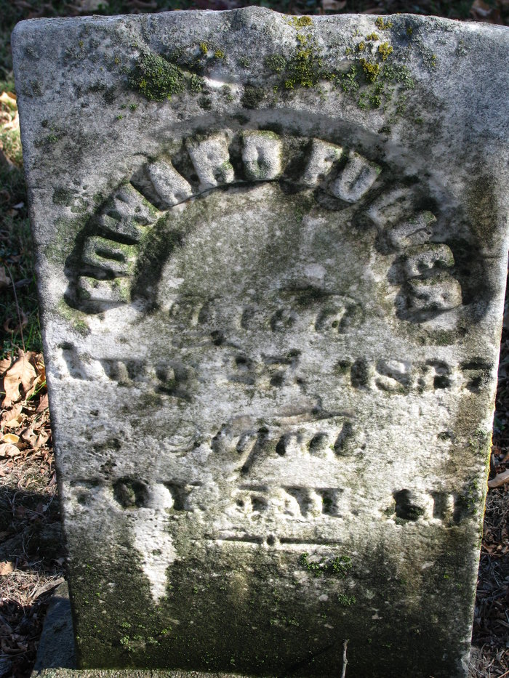
Photo by PLS

Edward S Fuller from tree Wolff Family Tree 2009
Birth 23 Mar 1767 Lancaster, Worcester, Massachusetts, USA
Marriage 13 Oct 1803 Berlin, Worcester, Massachusetts, USA
Residence 1830 Ashtabula, Ashtabula, Ohio, USA
Death 27 Aug 1837 Pleasant Mills, Adams, Indiana, USA
Father Edward Fuller (1721-1802)
Mother Ruth Shepard (Died 1834)
Spouse Susannah Maynard (1779-1843)

