Charley D. Fuller
November 21, 1880 – October 22, 1885

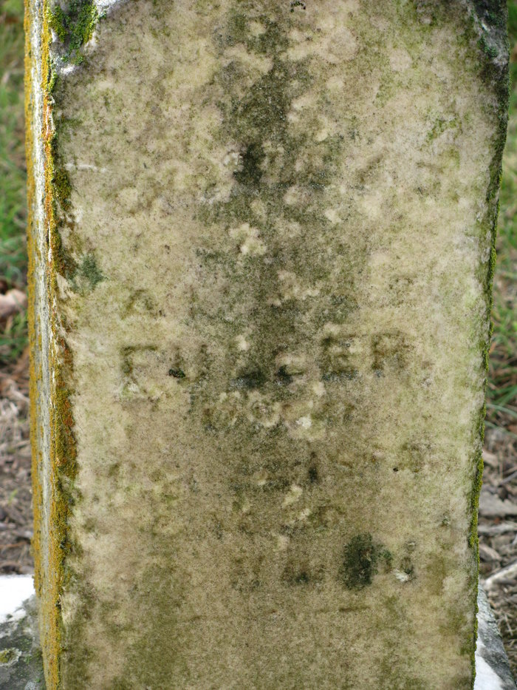
Photo by PLS

Charley D Fuller from tree Christina's Italian Heritage
Birth 21 Nov 1880 Adams, Indiana, USA
Death 22 Oct 1885 Adams, Indiana, USA
Father Albert Maynard Fuller (1854-1926)
Mother Sara Elizabeth Thompson (1855-1934)
129888 People 1 Record 1 Source

