Susan (Sponseller) Fortney
November 18, 1855 – October 13, 1938

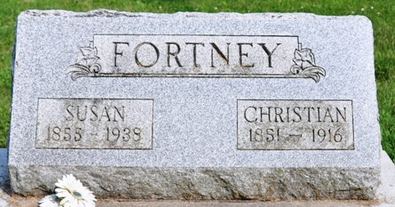
Photo by Deb Curry

FORTNEY

Mrs. Susan Fortney, 83, who formerly resided with a son, Frank G. Fortney of 4840 Montrose Street, died Thursday at the Decatur Hospital. In recent months, she had made her home with another son, Orlen S. Fortney at Pleasant Mills.
Survivors include two sons; a daughter, Mrs. Maggie Custer of Lakeland, Fla.; a brother, Samuel Sponsellor of Bryan, O.; a sister, Mrs. Julia Lewis of Three Rivers, Mich.; 11 grandchildren and 10 great-grandchildren.

Journal-Gazette, Allen County, Indiana
October 15, 1938

**
Indiana, U.S., Death Certificates, 1899-2017
Name Susan Fortney
[Susan Sponseller]
Gender Female
Race White
Marital Status Widowed
Age 82
Birth Date 18 Nov 1855
Birth Place Ohio
Death Date 13 Oct 1938
Death Place Decatur, Adams, Indiana, USA
Death Registration Date 1938
Father Sponseller
Mother Margaret
Spouse Christian Fortney
Informant Orlen Fortney; Pleasant Mills, Indiana
Burial October 16, 1938; Pleasant Mills, Indiana

**
Susan A Sponseller from tree Leape Family Tree
Birth 18 Nov 1855 Van Wert, Van Wert, Ohio, USA
Residence 1870 Tully, Van Wert, Ohio, USA
Marriage 1874
Death 13 Oct 1938 Decatur, Adams, Indiana, USA
Father George F Sponseller (1826-1894)
Mother Margaret Ann Freck (1829-1921)
Spouse Christian Fortney (1850-1916)

