John Rufus Fortney
November 2, 1913 – December 22, 1990

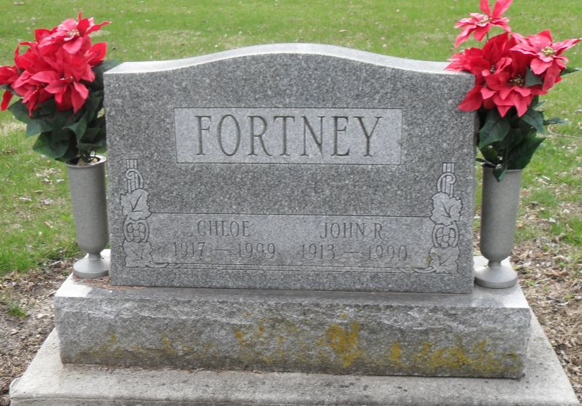
Photo by Stephen & Andrea Brangan

John R. Fortney, 77, died at 5:40 am Saturday at Lakeside Manor Nursing Home, Pleasant Mills. He retired in 1976 from Decatur General Electric after 17 years.
Surviving are his wife, Chloe E., a daughter, Darlene Myers of Decatur, a sister, Christena Dolch of Decatur; two brothers, Russell of Berne and Harry of Palmetto, Fla.; two grandsons; and four great-grandchildren.
Services at 10:30 am Monday at Zwick-Sefton & Jahn Funeral Home, Decatur. Calling from 2 to 5 and 7 to 9 pm today. Burial in Pleasant Mills Cemetery. Memorials to Mt. Zion United Brethren Church in Christ Church, Bobo.

Journal-Gazette, Allen County, Indiana
December 23, 1990
Page 16A

