Christian Fortney
September 25, 1851 – April 30, 1916

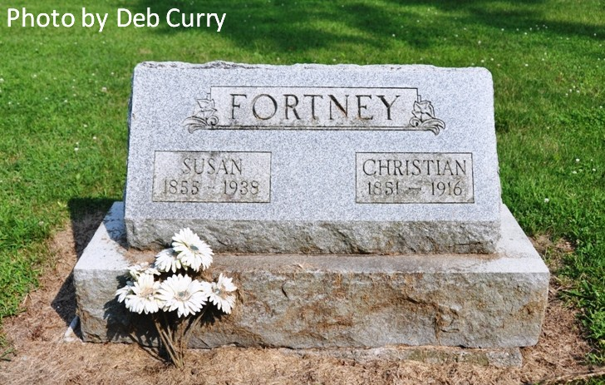
Obit from Karin King

DIES OF HIS INJURIES
Christian Fortney, of Adams County, Crushed Under Scaffold
DECATUR, Ind., May 2 - Christian Fortney, aged 68, a long-time and widely-known resident of St. Mary's township, this county, is dead at his home of injuries received last Saturday at the Painter home, near his own residence, while he was assisting in the task of raising a sick horse. A scaffold that had been erected for the purpose gave way under the weight of the horse and crashed to the ground. Mr. Fortney was struck on the head by a heavy timber and rendered unconscious. He was taken to his home and Dr. H. A. Duemling, of Fort Wayne, was called. The Fort Wayne physician said that nothing could be done to save the injured man's life. Mr. Fortney never regained consciousness. The deceased is survived by a widow and one daughter and two sons. Frank Fortney, of Fort Wayne, is one of the latter.
Fort Wayne Sentinel, Allen County, IN; May 2, 1916

