Chloe Anna (Essex) Fortney
November 27, 1917 – April 12, 1999

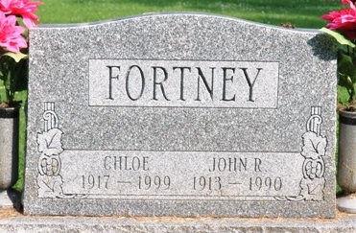
Photo by Deb Curry

Chloe Fortney, 81, of Pleasant Mills, died Monday, April 12, 1999, at Chalet Village Nursing Center in Berne. The Monroe native was a homemaker, member of Monroe United Methodist Church and active at Mount Zion United Brethren Church in Bobo.
Surviving is a daughter, Darlene Myers of Decatur; two grandchildren; four great grandchildren; and two step-great-grandchildren. Her husband, John R., two brothers and a sister preceded her in death.
Services are 10:30 a.m. Wednesday at Zwick & Jahn Funeral Home, Decatur, with calling from 2 to 9 p.m. today. Burial will be in Pleasant Mills Cemetery.
Memorials are to Chalet Village or Mount Zion United Brethren Church in Bobo.

News-Sentinel, Allen County, Indiana
Tuesday, April 13, 1999

**
Indiana, U.S., Death Certificates, 1899-2017
Name Chloe Fortney
[Chloe Essex]
Gender Female
Race White
Marital Status Widowed
Age 81
Birth Date 27 Nov 1917
Birth Place Monroe
Death Date 12 Apr 1999
Death Place Berne, Adams, Indiana, USA
Death Registration Date 1999
Father Merl Essex
Mother Sadie Lebrun
Informant Darlene Myers; daughter; Decatur, Indiana
Burial April 14, 1999; Pleasant Mills Cemetery; Pleasant Mills, Indiana

