John Fordyce
May 23, 1804 – February 5, 1866

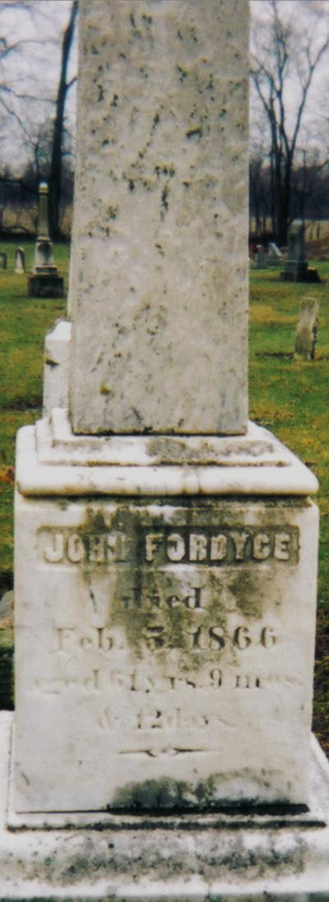
Photo by Annis J Hite Patee

John Fordyce from tree Birnell/Layman Family Tree
Birth 23 May 1804 Fayette, Pennsylvania, USA
Marriage 21 Feb 1837 Guernsey, Ohio, USA
Residence 1 Jul 1863 Indiana, USA
Death 5 Feb 1866 Adams, Indiana, USA
Father Isaac Fordyce (1766-1840)
Mother Susannah Jennings (1772-1831)
Spouse Mary Margaret Brown (1813-1868)

