Isaac N. Fordyce
August 5, 1828 – October 3, 1850

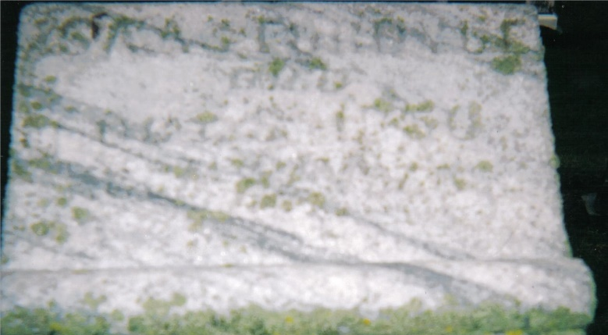
Photo by Annis J Hite Patee

Isaac N Fordyce from tree Diane Tree
Birth 5 Aug 1828 Guernsey, Ohio, USA
Marriage 1 Jan 1850 Allen, Indiana, USA
Residence 1850 Pleasant Mills, Adams, Indiana, USA
Death 3 Oct 1850 Adams, Indiana, USA
Father John Fordyce (1804-1866)
Mother Lydia Ann Parks
Spouse Samantha E Neptune Godard (1831-1883)

