Sarah Flagg
1838 - 1838

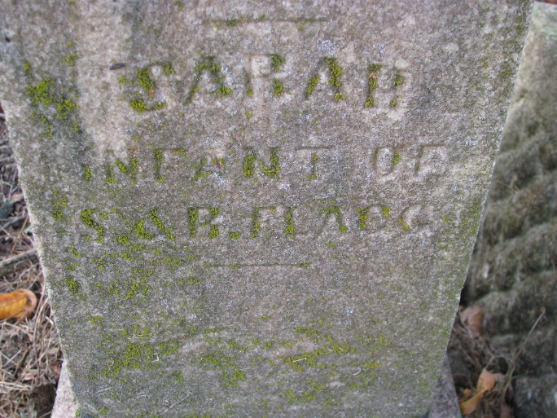
Photo by PLS

Sarah Flagg from tree Larry Ziemer Family Tree
Birth 1838 Pleasant Mills, Adams, Indiana, USA
Death 1838 Pleasant Mills, Adams, Indiana, USA
Father Samuel Flagg (1801-1882)
Mother Rebecca Wright (1804-1860)

