Samuel Flagg
October 6, 1828 – September 6, 1840

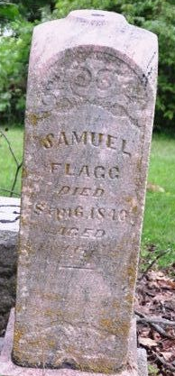
Photo by Deb Curry

Samuel Flagg from tree Rienhart-Seaman Family Tree
Birth 1829
Death 16 Sep (or Sept. 6) 1840 Indiana, USA
Father Samuel Flagg (1801-1882)
Mother Rebecca Wright (1804-1860)

