Romanus Flagg
September 25, 1830 – October 7, 1837

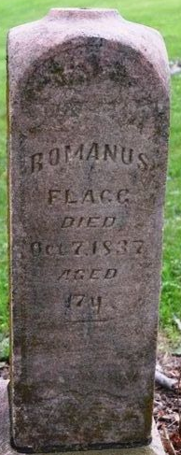
Photo by Deb Curry

Roman Flagg from tree Rienhart-Seaman Family Tree
Birth 1830
Death 7 Oct 1837
Father Samuel Flagg (1801-1882)
Mother Rebecca Wright (1804-1860

