Rebecca (Wright) Flagg
December 4, 1804 – February 8, 1860

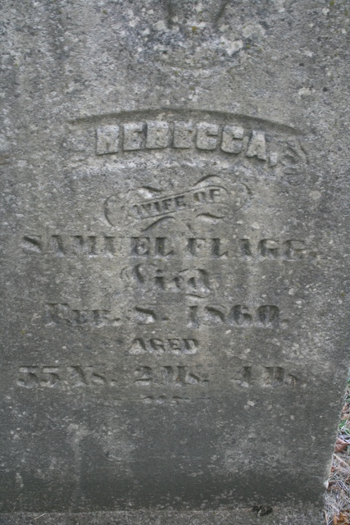
Photo by Jacquie Eisenhut

Rebecca Wright from tree Gillette-Yeager Ancestry
Birth 4 Dec 1804 Canada
Marriage 1826 Erie, New York, USA
Residence 1850 Adams, Indiana, USA
Death 8 Feb 1860 Decatur, Adams, Indiana, USA
Father William Wright (1767-1841)
Mother Nancy Button (1774-1818)
Spouse Samuel Flagg (1801-1882)

