Joseph A. Flagg
1828 – June 8, 1842

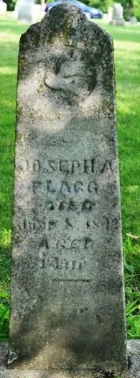
Photo by Deb Curry

Joseph A Flagg from tree Rienhart-Seaman Family Tree
Birth 1828 Ohio, USA
Death 8 Jun 1842
Father Samuel Flagg (1801-1882)
Mother Rebecca Wright (1804-1860)

