Arabella Flagg
February 5, 1836 – August 5, 1847

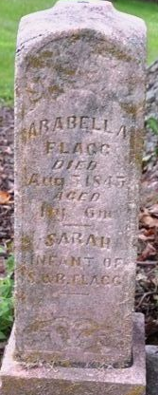
Photo by Deb Curry

Arabella Flagg from tree Rienhart-Seaman Family Tree
Birth Feb 1836
Death 5 Aug 1847 Indiana, USA
Father Samuel Flagg (1801-1882)
Mother Rebecca Wright (1804-1860)

