Sarah Ann (Roop) Fellers
July 13, 1836 – May 5, 1897

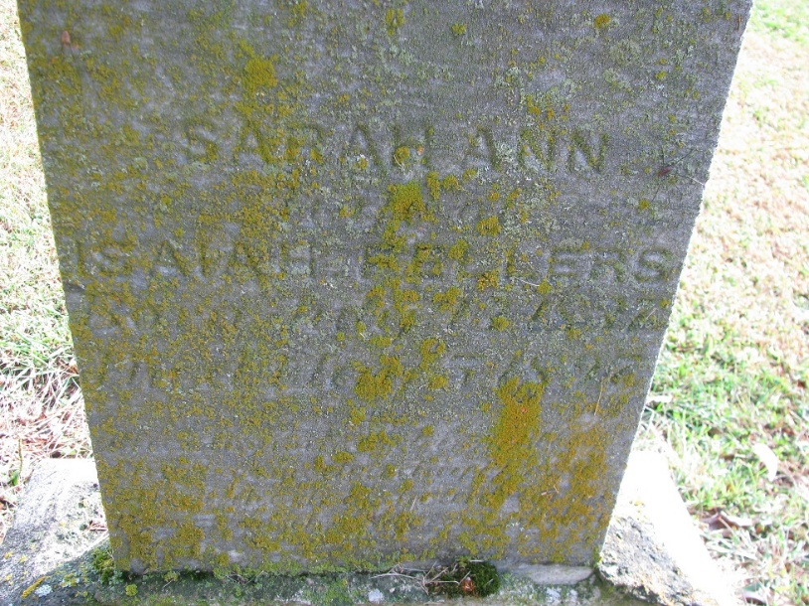
Photo by PLS

From: "Nola Rains" <blueheron46733@@yahoo.com> 5/7/2001

The obit for Sarah Ann Roop Smith Andrews Fellers, in full: "Mrs. Isaiah Fellers died early yesterday morning. She had been suffering for quite awhile with a complication of diseases, and for the past week her death has been daily expected."

Decatur Democrat, Adams County, Indiana
6 May 1897
**

Indiana Marriage Collection, 1800-1941

Name: John W Andrews
Spouse Name: Sarah Ann Smith; Marriage Date: 7 Oct 1865
Adams County, Indiana Index to Marriage Records 1845 - 1920 Inclusive Vo; W. P. A. Original Record Located County Clerks Off, Book: C, OS Page: 18
**

Collection: Michigan Marriages 1868-1925

Groom name: Isaiah Felters; Groom age: 52 years; Groom birth year: 1831; Groom birth place: Fairfield Co., Ohio
Bride name: Sarah A. Roop Andrews; Bride age: 45 years; Bride birth year: 1838; Bride birth place: Seneca Co., Ohio
Marriage date: 11 Jul 1883; Marriage place: Sturgis, St Joseph, Michigan
Film number: 2342473; Digital GS number: 4207684; Image number: 229; Reference number: v 3 p 262 rn 356
**

Sarah Ann Roop from tree Mossinghoff

Birth 13 Jul 1836 Indiana, USA
Residence 1870 Allen, Indiana, USA
Marriage 11 Jul 1883 Sturgis, St Joseph, Michigan, USA
Death 5 May 1897 Indiana, USA
Father Joseph Roop (1808-1876)
Mother Elizabeth Kemp (1816-1891)
Spouse William Smith (1828-1864)
Spouse John W. Andrews (1823-1901)
Spouse Isaiah Fellers (Born 1831)
3389 People 9 Records 20 Sources

