James Franklin Faust
February 9, 1820 – August 23, 1896

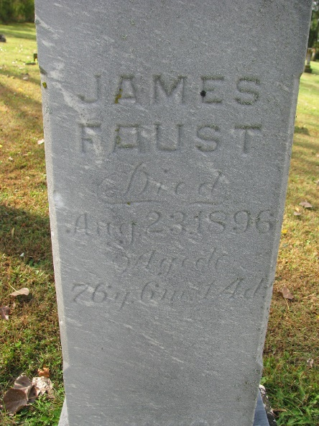
Photo by PLS

The funeral of James Faust occurred here Monday afternoon. His remains were laid to rest in the Pleasant Mills Cemetery.
Decatur Democrat; Adams County, Indiana
August 27, 1896
**
James Franklin Faust from tree Brock Family Tree

Birth 9 Feb 1820 Butler, Ohio, USA
Marriage 1864
Residence 1880 Adams, Indiana, USA
Death 23 Aug 1896 Pleasant Mills, Adams, Indiana, USA
Record information.
Father George Frederick Faust (1772-1852)
Mother Ann Nancy Landis (1768-1844)
Spouse Elizabeth Gard (1836-1868)

