Elyzabeth (Gard) Faust
August 22, 1836 – February 12, 1868

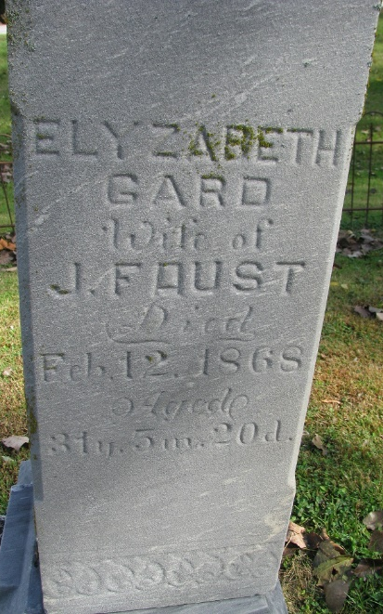
Photo by PLS

Elizabeth Gard in Cowan Family Tree
Spouse James Franklin Faust
Father John Gard
Mother Nancy Sprout
Children Franklin Philip
Birth 22 Aug 1836 Ohio, USA
Death 12 Feb 1868 Pleasant Mills, Adams, Indiana, USA
Residence 1850 Dixon, Preble, Ohio, USA

