Phillip Everett
July 18, 1839 – December 31, 1876

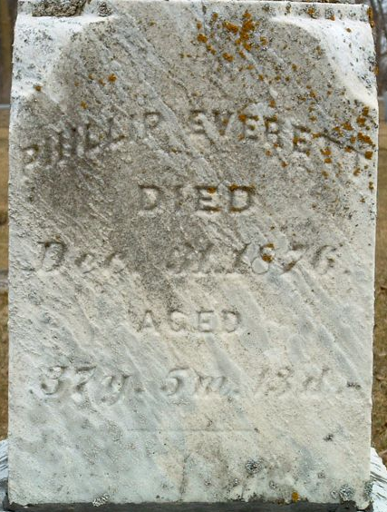
Photo by PLS

Phillip Everett from tree Fenstermacher/Reese/ Forney/Watts Family Tree
Birth 18 Jul 1839 Pennsylvania, USA
Residence 1870 Adams, Indiana, USA
Marriage 2 Apr 1871 Willshire, Van Wert, Ohio, USA
Death 31 Dec 1876
Father Joseph Everett (1815-1878)
Mother Mercy Viola Watts (1813-1887)
Spouse Hannah Amanda Frisinger (1851-1912)

